**Classroom Activity 1: Prepare an application development plan for the Portfolio Website.**

**1. Application Development Model:**

Using the Waterfall model for a portfolio website can be beneficial for several reasons:

* **Clear Requirement:**
  + Clear Requirements: Portfolio websites typically have well-defined requirements, such as showcasing specific projects, including an "About Me" section, and having a contact form. The Waterfall model excels when requirements are clear and unchanging.
* **Sequential Approach**:
  + The Waterfall model's sequential approach ensures that each phase (requirements, design, implementation, verification, and maintenance) is completed before moving on to the next. This can lead to a more organized and methodical development process, which is suitable for straightforward projects like a portfolio website.
* **Ease of Management:**
  + With its structured nature, the Waterfall model makes project management easier. Progress is measurable through clearly defined milestones, and project status is easier to communicate to stakeholders.
* **Documentation:**
  + The Waterfall model emphasizes thorough documentation at each stage. This is beneficial for a portfolio website as it ensures all design choices, content, and features are well-documented and can be easily referenced or updated in the future.
* **Quality Assurance:**
  + Testing is a dedicated phase in the Waterfall model, which can lead to a higher quality product. For a portfolio website, this ensures that all links work, the design is consistent, and the website performs well across different devices and browsers.
* **Predictability:**
  + Since the Waterfall model involves detailed planning and a set timeline, it offers predictability in terms of project duration and cost, which is valuable for clients or stakeholders who need a reliable launch date.
* **Minimal Changes:**
  + Portfolio websites often do not require frequent changes once they are live, making the rigidity of the Waterfall model less of a disadvantage compared to projects that require iterative development and frequent updates.

**2. Model & Tools-Technologies:**

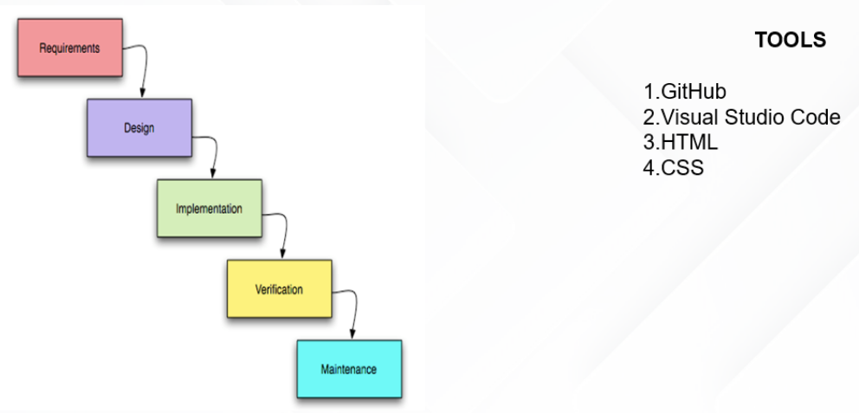

**TimeLine Chart:**

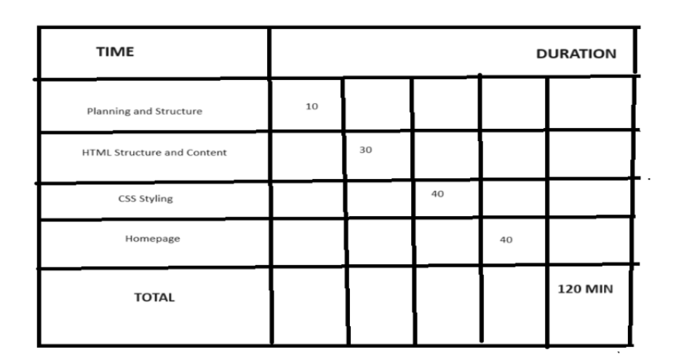

**Project Structure:**

* **index.html​**
* This file serves as the landing page or homepage of your portfolio.​
* Include a brief introduction, links to other sections (About Me, Portfolio, Contact), and key highlights.​
* **about.html**
* This page provides detailed information about yourself.​
* Include a biography, skills, education, and any other relevant details.​
* **portfolio.html​**
* Showcase your projects on this page.​
* Each project can have a brief description, images/screenshots, and links to live demos or GitHub repositories.​
* **contact.html​**
* This page allows visitors to get in touch with you.​
* Include a contact form (if possible) or provide contact information such as email address, social media links, etc.​
* **style.css​**
* A central stylesheet that defines the visual appearance and layout of all HTML pages.​
* Include styles for typography, colors, layout positioning, responsiveness (using media queries), and any animations or transitions.

**Flowchart:**

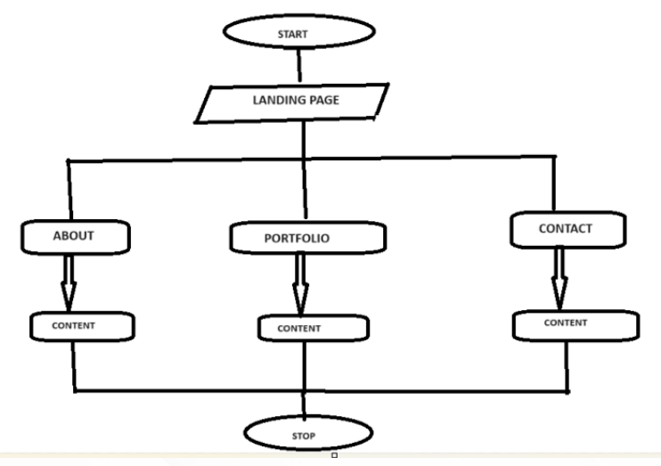

**Wireframe:**

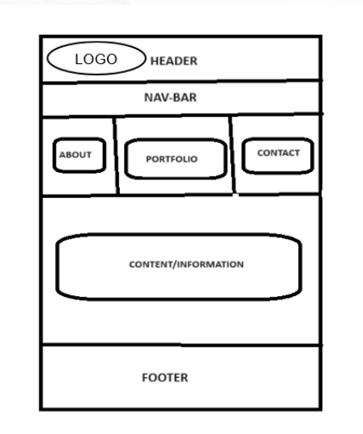

**Code:**

[**https://github.com/radhauma/Karanportfolio**](https://github.com/radhauma/Karanportfolio)